121 Dog and Puppy Training
https://www.animalkind.co.uk/dog-and-puppy
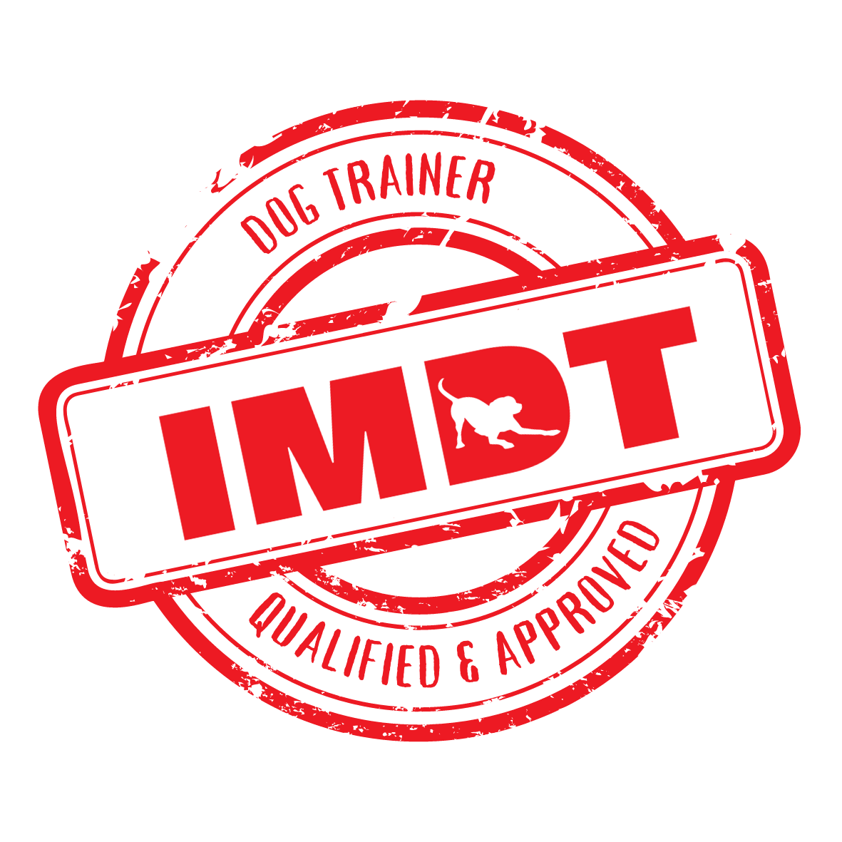

Animal Kind Dog Training and Behaviour, based at Solihull Riding Club, in Dorridge, has been offering all-around training for puppies, adolescent and adult dogs since 2010, to turn them into calm, happy dogs.
We are unique in that we offer 121 Dog and Puppy Training, and Behaviourist sessions, as well as Group Classes - depending on what we think your dog would benefit from and what you need.

Chris and Helen have provided 121s to thousands of dogs and puppies and their owners for issues ranging from general puppy training, socialisation, obedience, agility, dog-to-dog aggression, and settling in new rescue dogs, having fostered 9 of their own. They were personally taught by Steve Mann, author of Easy Peasy Dog Squeezy. Chris provides behavioural expertise to Animal Kind’s training programmes, having gained a Masters degree in Animal Behaviour in 2017 from the University of Newcastle, as well as being awarded a Dogs Trust Behavioural Scholarship in 2024, becoming the first of six people to ever do so.

The 121 Training starts with a Bumper Puppy Power session if your pup is 6 months or younger, or for dogs over 6 months, we call it an Assessment and First Training session. These are for:

- Nipping, jumping, chewing, consuming the wrong items, toilet training, and general training issues.
- General Obedience issues, inside or outside the house, such as household barking and jumping.
- Settling: Settling in a rehomed dog, and/or adding a new pet into your multi-dog household.
- Thinking about Group Classes now or as a goal to aim for? You can use our 121 Puppy or Dog Training as a springboard to join our classes with other owners, or get a £10 discount when you combine 121s and Classes: https://www.animalkind.co.uk/classes

We have special 3-session packages for Recall, Lead Walking and Separation Prep (see page 4):
- Recall: Getting confident enough to move start off-lead walks, or remedying existing recall issues: We have private land and access to 5 calm sociable dogs to help proof your dog’s recall.
- Separation Prep: Getting ready for letting pup or new dog being left at home alone. Although if you already have significant pre-existing issues, please see our behaviour services: https://www.animalkind.co.uk/behaviourist

To arrange a session please fill out this form: https://www.animalkind.co.uk/contact-us
Or call Chris Wills IMDT BSc MSc on 07542 150 036 or email Helen and Chris via info@animalkind.biz

“As new dog owners the 121 sessions we had with Helen were a life saver!,” said Sarah Manson with Boxer Daisy. “She gave us some invaluable advice for setting up the house for our new puppy and got our training off to a great start.”

Booking the First Session
https://www.animalkind.co.uk/book-121s

This First Session is normally held at your home, in which we set up for success, diagnose the cause of problems and create a training plan to help you towards a brighter and more relaxed future. Following on after your first session, we offer follow ups which can be paid by monthly instalments.

Service | Cost | Covers (plus much more besides)
Bumper Puppy Power  (pups six months or younger)  Covers the essentials for your pup. We tailor-make the first training session to fast track your pup’s progress. Held at your home, lasting approx. 2 hours. | £105 | Essentials such as: Non-nip toy play, leaving dangerous items, toilet training, sleeping quietly through the night, play with children and other pets, including socialisation advice.  This can be used as an assessment if you are worried about more serious behaviours such as biting or guarding.
Follow Up Sessions | See page 3
Assessment and First Dog Training Session  (dogs over 6 months)  This assessment allows us to get to know your dog or dogs (no extra charge for multi-pet households), the challenges and your goals. This lasts around 2 hours and is held at your home or our private training locations. | £105 | This is your first step to developing a calmer, generally more obedient dog. This session is used to assess behaviour in a controlled environment, and to begin training straight-away.  We diagnose the problems, start your training plan, and determine how many sessions we expect you need.  We go for a walk as part of this session.
Follow Up Sessions | See page 3

“Chris and Helen have without a doubt had a fantastic impact on the behaviour of our puppy,” said Oli Hill with working Cocker Spaniel, Magnus.

Development Packages and individual Follow On Sessions

Following on from your first session, you can either do one-off follow-up sessions – on a pay as you go basis - or benefit from the regularity, security and discounted price of 6 month follow-up packages.

These allow us to guide your puppy, teen or adult dog’s training, development and socialisation for an appropriate-length period that we will advise you upon. The 6-month packages can be paid by monthly secured direct debit payment, or upfront in one go if you prefer. During the 6 months package, every month you will get an in-person, age-appropriate training session as well as advice to help your dog’s development into a calm, family-friendly dog.

Packages include remote support between sessions, with direct access to tips from us via the phone or Whatsapp, and a useful bank of clips and videos. Follow-up sessions last approx. 60 minutes and are held at your home, in parks, or our private and spacious training fields in Dorridge and Lapworth.

Service | Cost | Covers (plus more besides)
Puppy and Dog  Follow-Up Packages:  6 Months / six sessions  - Receive a discount for signing up to a package of 6 sessions over 6 months.  - Suitable for more serious training issues, and if you have several ongoing training issues.  - Also suitable for settling in a new rescue dog, so long as no major issues have presented themselves. | £75 per month | After your first session you can opt to go on a 6 months training package with monthly sessions and follow up support on email, phone and Whatsapp during that time.  - Monthly training sessions of approx. 60 minutes.  - Guided training and development: initially the sessions are held in our private locations, and then in more public spaces, such as parks, to make the training more life-like.  - To pay in monthly instalments, sign up here: https://pay.gocardless.com/BRT0003VGCDJB51
Or Pay as you go option (ie individual follow up sessions, without signing up to a package): | £85 per session | Paid before each follow up session

“We have used Helen from Animal Kind for both individual and group puppy training. She came highly recommended and we were not disappointed. Helen clearly has a great deal of knowledge and experience in dog training. She obviously loves dogs and her training ethos is to train them by using their natural instincts. We would have no hesitation in recommending both Helen and Animal Kind in general,” said Julie and Mark Greaves with Beagle, Elsa.

Special Packages for Recall, Lead Walking and Sep Prep
https://www.animalkind.co.uk/book-121s

Despite what the books and YouTube dog trainers may say, Recall, Lead Walking and Separation Preparation can be hard to master. And it isn’t just about being top dog or holding the lead in a certain way - the truth is, some dogs (and owners!) struggle with these skills more than others. Over the course of 3 sessions we will improve your handling, confidence and your dog’s training:

- Initially held in low distraction environments, such as private land at Solihull Riding Club, Dorridge, where we have an office or our private training field in Hockley Heath.
- Use of increasing distractions created by ourselves, which include bringing calm dogs who are trained to help, and enjoy helping your dogs: Including Luna Labrador, Izzy and Archie.

Service | Cost
Recall  Improve your dog’s recall to voice and to a whistle (included and yours to keep). These 3 sessions will build your abilities and your dog’s reliability, as move from recall in private land to public spaces. | £225  Can be paid in a lump sum or three instalments:  https://pay.gocardless.com/BRT0003H9GCJ3A5
Lead Walking  We provide tailor-made advice on equipment, and bespoke guidance and training to improve your dog’s lead walking. These 3 sessions will help you as we move from quieter locations to busier ones. | £225  Can be paid in a lump sum or three instalments:  https://pay.gocardless.com/BRT0003H9GCJ3A5
Separation Prep*  Prepare your dog for being content without you there. *If your dog already has (or is suspected to have) separation related distress, you will need our Behaviourist Service: https://www.animalkind.co.uk/behaviourist | £225  Can be paid in a lump sum or three instalments:  https://pay.gocardless.com/BRT0003H9GCJ3A5

“Anyone who has seen Nellie both before and after training with Chris comments that she's like a different dog. Walking with her is now a pleasure rather than a chore and that's all that I wanted. Chris has a lot of patience, he put me at ease, gave me encouragement and never criticised even when I think I was probably being a bit slow at picking things up.” said Kelly Hall, with Weimaraner Nellie.

“We particularly like the approach of positive reinforcement, not punishment for bad behaviour, as it builds a much more trusting relationship and closer bond with your dog,” said Mark Smith with Buddy.

Payment and Terms and Conditions

- Any questions then please email us at info@animalkind.biz or call Chris on 07542 150 036

- Remember you get a £10 discount off the below if you have already signed up to Group Classes. Type in DISCOUNT10 when paying via our website.

- To confirm a booking of a first session, please pay £105 for a Bumper Puppy Power session or an Assessment and First Training Session to:

Business Bank Account of:
Animal Kind Dog Training Ltd
Account Number: 86012117
Sort Code: 60-83-71

- Our follow up packages are based on the number of sessions (e.g 6 sessions), usually spread out approximately once per month. Follow-up sessions can happen more or less frequently, depending upon the issue, and you will receive email and WhatsApp or SMS Text support between sessions, during normal office hours, for as long as you need.

- Outside of a package, you can book one-off (in person) follow ups for £85.

- No mileage charge within 5 miles of Dorridge, B93 8QE. Charged at £1 per mile thereafter.

- In the rare case that during the Bumper Puppy Power/ Assessment and First Training Session, we decide that you will be better suited to our Behaviourist Services, there may be an additional charge of £90 for us to write behavioural reports and liaise with your vet.

Check out Facebook (@animalkinduk) and Instagram (@animalkinduk) for photos and videos of our various dog training classes to inspire you to start or continue your journey with us. And subscribe to our YouTube channel: https://www.youtube.com/channel/UCBqaEa0kBIXyvPuS6mxmP0A

